Topeka/Shawnee County
National Night Out 2024

Grant Information Packet
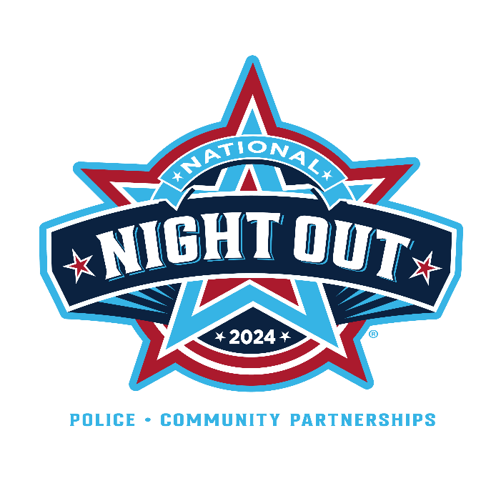

Coordinated by:
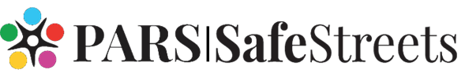

Get NNO Information in Several Ways!
parstopeka.org/safestreets
info@parstopeka.org | 785.266.8666
Facebook: PARS Topeka

Welcome!

WELCOME! In the enclosed materials are items you will need if your grant application is approved, and your neighborhood will be hosting a National Night Out (NNO) celebration for 2024. Items included in this document will help you in planning a successful National Night Out event.

In Topeka/Shawnee County, the National Night Out Celebrations are put on BY the neighborhoods, FOR the neighborhoods. These are alcohol and drug-free events. Though each celebration is autonomous, neighborhoods come together to plan the events. This is truly a collaborative effort between neighborhoods, law enforcement, Prevention and Resiliency Services/Safe Streets, and other community partners.

Who Can Participate
We encourage all neighborhoods, including apartment and retirement complexes, to participate in NNO Events. Apartment and retirement complexes will need to have an authorized manager involved in planning the event and on duty during the event. While you do not have to be part of an organized neighborhood group to participate, we encourage Neighborhood Watches, Neighborhood Improvement Associations, Neighborhood Associations, and Homeowners Associations to organize events for their respective areas. We recognize that some events may occur close to others and ask groups to work together to avoid overlapping events in their immediate vicinity.

Fundraising for National Night Out

Raising Funds
You are free to raise donations of money, door prizes, or supplies. The donations you raise are yours and do not need to be shared with all neighborhoods. A letter you may use to solicit donations from businesses for your event is included in your folder. If you would like a digital copy email info@parstopeka.org with the subject of Digital Solicitation Letter.

If you contact a business for donations, please leave your name and phone number, not Prevention and Resiliency Services, so the business can call you to pick up donations. Prevention and Resiliency Services has received calls in the past few years about donations, but it is difficult to find the neighborhood that requested them.

If a business wants to use a “non-profit ID number” for tax purposes, the monetary donation must be submitted to Prevention and Resiliency Services and a check will be written to the neighborhood at the time of the NNO event. The business should call Prevention and Resiliency Services at 785.266.8666 to request any further information they require.

No Charging for NNO Events or Activities
NNO events shall be free to your neighborhood. No admission charges or raffle ticket sales are permitted.

Promoting Your Event

Advertising Your Event
It is important that you market your event. If you are in an organized neighborhood group, start there by inviting everyone! If you do not have a group, start by inviting your neighbors.

Reach out to churches, schools, service clubs, or organizations in your neighborhood to see if they will include information about NNO in their bulletins or handouts.

Another effective way to market your efforts is through flyers. Prevention and Resiliency Services can create and/or provide copies of flyers to assist in this regard.

Flyers for 2024
- All flyers will be the same this year. The flyer will be created and then each neighborhood's information will be added to the flyer and printed.
- Prevention and Resiliency Services will need to know the details of your event: time, location, and if they need to bring something. We will also need to know how many flyers you need printed and the date you would like them by.
- Flyers will be prepared and ready for pick up at the PARS office at 2209 SW 29th Street by the requested date.
- Flyer information must be submitted to PARS one week before you want to pick them up. You can submit flyer information by emailing info@parstopeka.org.

Proper use of NNO Logos

The National Night Out (NNO) name or NNO trademarks (logos) may not be reproduced on any wearables such as shirts, caps, or any other promotional goods or products. It can and will be on your flyer. If you have any questions, please direct them to Prevention and Resiliency Services. Please see the Trademark Fact Sheet included in the packet (next page) for full details.

Trademark Fact Sheet
Guidelines for Using “National Night Out”

As a registered participant in the “41st Annual National Night Out” (NNO), you may use the trademarks, slogans, and names (collectively referred to as the “Marks”) of the National Association of Town Watch (NATW) and NNO, provided that they are used in accordance with the guidelines set forth below:

VERY IMPORTANT! The NNO Name (or any variation thereof) or NNO Marks may not be reproduced on any wearables such as: shirts and caps — or on any other promotional goods or products. If you have any doubt about whether your intended use of the Marks is prohibited, please contact the NATW office. Violators will be subject to legal action.

The Marks may be used on literature such as flyers, posters, announcements, and newsletters in connection with the promotion of NNO 2024.

The name “National Night Out” (whether it appears in the text or as part of the NNO logos), slogans such as “America’s Night Out Against Crime,” and the graphic logos and themes of NNO may be used in accordance with these guidelines on a limited basis by nonprofit organizations and agencies officially registered with NATW. Use by all others is prohibited. As described above, the NNO name (or any variation thereof) or Marks, may not be reproduced onto any type of promotional product.

Use of any “National Night Out” Marks by any commercial, for-profit company, except for those officially approved and recognized by NATW, is strictly prohibited. If your organization enlists the assistance of a company to support your local NNO (e.g., funds, in-kind donations), that is permitted. However, that company may not have its participation/association with NNO publicly advertised, displayed, or promoted, unless it is registered as an official NNO sponsor with NATW’s national office - or unless NATW extends advanced written approval.

Please make sure that all companies assisting you with National Night Out in your area are advised of the above and are provided with a copy of this “Trademark Fact Sheet.”

NATW retains all ownership rights in the Marks. NATW reserves the right to restrict or control the use of the Marks. Unauthorized use of the Marks will be subject to legal action by NATW under applicable federal and state laws.

Event Logistics

Block Party Permit Application & Street Closing Procedures
A Block Party Permit Application must be filled out and turned in to the City of Topeka if you are planning to close off streets or sidewalks for your National Night Out event. A copy of this application can be found in the folder or on our website (parstopeka.org). Each neighborhood will have to pay a $25.00 fee if you fill out one of these applications. This application fee can be covered by the grant money that you receive. Please include this fee in your budget on the grant application if it is necessary for your event.

Each neighborhood that plans to close a street or sidewalk for its event must follow all the instructions listed on the Block Party Permit Application. You will be responsible for contacting a company listed on the application for barricades and for paying for the barricades. This can also be paid with your grant money (This is another expense to record in the budget on your application).

This application and a payment of $25.00 must be turned in to the City of Topeka City Clerk’s Office, 215 SE 7th Street, Room 166, 20 business days or 4 weeks prior to the event. If you have questions on the form or filling it out email cclerk@topeka.org or call 785-368-3940.

Insurance
Insurance is not required unless the event is occurring on a closed-off street. If the event is being held in the street, INSURANCE IS REQUIRED. If you will be using barricades to close the street, a person must monitor them for the duration of the event. It is easiest to hold the event in a driveway, yard, or public area.

Amplified Music/Noise Ordinance
The noise ordinance is included in the Block Party Permit application. If there is going to be amplified noise at your events such as a live band, a DJ, or loudspeakers you will need to fill out this portion of the application.

Portable Restroom Facilities
For portable restroom facilities call A1 Rental for Johnny on the Job at 785.478.3788. Costs will be the individual responsibility of those neighborhoods making requests. Grant money can be used to pay for portable restrooms. (Please include in your budget if you plan to rent one for your event.)

Reserve Community Center or Park (Shawnee County Parks and Recreation)
In the folder or on our website you can find the Shawnee County Parks and Recreation application. This form must be completed and submitted 30 days prior to the event. Complete the application and email it to riley.shafer@snco.us or deliver it to Riley Shafer at 3137 SE 29th Street, Topeka, KS 66605.

National Night Out T-Shits
Prevention and Resiliency Services will place an order for NNO 2024 T-shirts on June 14 @ 4:00 p.m. The prices for these shirts are $13.00 for youth sizes Small, Medium, and Large, and adult sizes Small, Medium, Large, and XL, $16.00 for 2XL, $17.00 for 3XL and $18.00 for 4XL. The order will be placed by Prevention and Resiliency Services and the money collected at that time. Please see the t-shirt order form in the folder.

Pick Up Items
If you order t-shirts, we will notify you via email that the shirts are ready for pick up. PARS staff will designate times for neighbors to pick up t-shirts.

If you would like to use NNO yard signs, they will be available to pick up with the T-shirts. If you would like to borrow signs, you can also come by our office (2209 Sw 29th Street) on July 31st, August 1st, or August 2nd between 9 a.m. and 4:00 p.m. to pick up the signs. If these times will not work for you then you will need to email info@parstopeka.org and set up an appointment to pick up the signs.

After the event
After your event is held you will have two weeks to turn in your expenses, copies of your receipts, the number of participants, and pictures of the event. An expense form will be given out with the award checks. You can turn all of this in by hand delivering to PARS or by scanning the documents and emailing them to info@parstopeka.org. Unaccounted funds remaining from neighborhood grants are to be returned to PARS.

Public Safety Resources

Law Enforcement
Historically, a neighborhood has been able to count on having a law enforcement officer and, if desired, Topeka Fire Department personnel. This year you will need to reach out to those agencies and provide them with all the details of the event. Since we are having the community event, it is at the discretion of each department regarding whether they have the workforce to send to the events.

Requests for these events should be made 30 days prior to your event. The request must include the name of the neighborhood, address of the event, time of the event, and contact name and number.

Sheriff’s Office – contact Sgt. Jay Harmon by e-mail at henry.harmon@snco.us
- Officers
- K-9 Units
- Mounted Posse.
Topeka Police Department – contact Sgt. Mike Burns by e-mail at mdburns@topeka.org

Topeka Fire Department – contact Shauna Williams by e-mail at stwillia@topeka.org

Kansas Highway Patrol – contact Lt. Candice Breshears by e-mail at candice.breshears@ks.gov.
- KHP Rollover
- Convincer

Donations for Food

Donations cannot be guaranteed, but feel free to contact these agencies if you are interested in trying to obtain items for your event. They have generously offered to support the community-wide event on National Night Out, August 6th at Westridge Mall. You are encouraged to write food items needed into your budget on your grant application.

Reser’s Fine Foods
GivingInTopeka@resers.com

Dillons
https://thekrogerco.versaic.com/registration

Important Dates

Calendar
Date | Day | Activity
April 23, 2024 – 6 to 7 PM | Tuesday | Planning Meeting
May 28, 2024 | Tuesday | Grant applications due to PARS
June 14, 2024, by 4:00 PM | Friday | T-Shirt orders due to PARS
July 31st – August 2nd 9 to 4 PM | Wed – Fri | Pick up signs from PARS
August 6, 2024 – 4 to 7 PM | Tuesday | City-Wide NNO Celebration at West Ridge Mall
August 6th – September 29th |  | NNO Neighborhood events
Two weeks after your event |  | Expense report, copies of your receipts, the number of participants, and pictures of the event turned in to the PARS office or via email at info@parstopeka.org

Name | Neighborhood and  Phone | Youth  Small  $13.00 | Youth  Medium  $13.00 | Youth  Large  $13.00 | Adult  Small  $13.00 | Adul  Medium  $13.00 | Adult  Large  $13.00 | Adult  XL  $13.00 | Adult  XXL  $16.00 | Adult  XXXL  $17.00 | Adult  XXXXL  $18.00 | Total  Cost
National Night Out T-Shirt Order Due by June 14, 2024
Please indicate the number of t-shirts you are ordering under each category

Please indicate the number of t-shirts you are ordering under each category

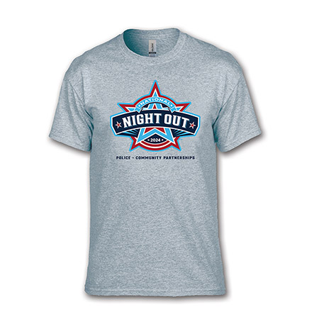
T-shirt orders and money are due to Prevention and Resiliency Services by June 14th by 4:00 p.m.

Full color, comfortable, and durable sport grey tee made from a 50% cotton/50% polyester blend. Moisture-wicking t-shirts are cool, dry, and comfortable. Celebrate NNO with the official 2024 shirt.

NNO T-shirts prices are:

Youth Small Medium and Large $13.00
Adult Small, Medium, Large, Extra Large $13.00
Adult XXL $16.00
Adult XXXL $17.00
Adult XXXXL $18.00

